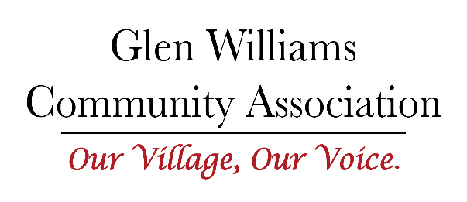
GWCA MISSION STATEMENT:
To maintain the hamlet character of Glen Williams by
engaging and communicating with its residents and other stakeholders.

Board Meeting Minutes
Held via Zoom
Wednesday, April 27, 2022

Present:
Joan Griffin, Claudia Russell; Aimee Cichocki, Fernanda Amaral, Derek Remes, Jenny Humphries, Anthea Hoare
- Welcome to all.
- Motion to approve and accept the agenda. All in favour.
- Motion to accept the minutes of the meeting of March 30, 2022. Noted that the Parks and Trails Terms of Reference was submitted but not included. Minutes accepted with the correction acknowledging that a Parks and Trails Terms of Reference had been submitted. All in favour.

- Canada Day Discussion held:
  - Canada Day going ahead, board agreed we would participate with a booth.
  - Acknowledged that we have been asked to support the Town Hall with communication through our Newsletter and FB page.
  - Agreed we will have a booth for information and membership purposes, but also want to use the opportunity for fundraising.
  - Fundraising suggestions tabled included:
    - Mark Rowes book, sell for $25, retain $10, balance to Mark
    - Possible GWCA merchandise, (ball Caps, t-shirts, etc.)
    - **Glen Maps, (Claudia to look into this)
    - **Bookmarks (Elizabeth Bailey)
    - **Parks and trails maps (Fernanda to pursue)
    - **Copies of newsletter
    - **Freezies (Anthea)
    - **Water (Claudia)

  - Anthea asked that we check with The Town Hall Board to avoid competition. Joan recommended that GWCA only invests in two things as there is only a little money in the kitty.
  - General discussion on the plan, and it was decided that it must all be settled in the next 2 weeks. Jenny, Anthea, and Fernanda will see if there are any companies that might donate items that we could sell/give away.
  - Agreed that we do not want to compete with Town Hall re any merchandise they are selling.

- Committee Action Plans
- The Development Action Plan was reviewed as a good sample of the plans
- No other Action Plans are ready
- Committee Leads asked to submit Action Plans within next two weeks

- “May 18th Open Meeting” Discussion:
- To be in the Town Hall, May 18, 6:30-9:00 pm.
- Annual plans to be ready, each lead will present.
- Fernanda suggested the attendees be asked for their ideas for focus in 2023.
- Goal is to share what we do, and how, along with Terms of Reference and Action Plans.
- We will provide water and have copies of the newsletter available.
- Start by intro of the board, what we do, mission statement, etc. Position this to show that we have been listening to the residents.

- Other Business:
Lynn Johannson has a meeting on May 15th and Joan will attend.
Don, Joan, and Derek will meet with the Town regarding the ‘102 Development’ issues list.

7. Meeting closed at 8:46 pm

