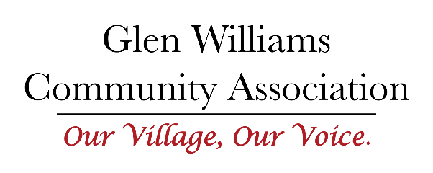
Minutes of the Board Meeting held via Zoom
February 23, 2022

Present:
Claudia, Aimee, Derek, Joan, Fernanda, Jenny, Kate
Regrets:
Anthea

Opening remarks from The Chair:
Welcome to all. The agenda and the meeting will be different this evening and in March – as outlined in the earlier email. The officers have held two meetings and hope to introduce some new processes to help the board’s operations and to ensure there is an understanding by all members of the legal intent of the GWCA.

For Decision:
- Agenda: Motion to Accept: Moved by Fernanda, Seconded by Joan. Passed
- Minutes of January 26, 2022: Motion to Approve: Moved by Derek, Seconded by Aimee. Passed
- Motion to Retain Party Status for the McMaster-Megan development. This is in follow-up to discussion in December 2021 and January. Moved by Kate, Seconded by Fernanda. Passed.

For Discussion:
- Several documents were attached to the original meeting request sent via email on January 25, 2022. These documents were created by the officers after two planning meetings. Information included in the documents were the mission statement of the GWCA and the Articles of Incorporation (formerly known as Letters Patent). The Articles of Incorporation lay out the legal intentions of the GWCA as approved by the Provincial Government.
It became clear to the officers that the board needed to ‘reset’ our processes and the understanding of the GWCA to achieve compliance with the Articles of Incorporation. It was agreed that the board would revisit its mission statement to ensure it aligns with the Articles of Incorporation. The mission statement needs to be clear and concise. A new draft will be brought forward to the next meeting after another officer meeting. It was clear at the end of the discussion that there was general understanding and acceptance of the Articles of Incorporation as written.
Processes for communication and ‘housekeeping’ for the GWCA going forward were also outlined. Changes and corrections to draft minutes must be provided to the secretary in writing prior to the next meeting. Communication processes will be decided by the Communications Committee. Additional information about public information sharing, duties of the officers, and an annual plan will be provided at the March meeting. What was key for this meeting was for everyone to understand and agree on the purpose and limitations of the GWCA.
- Documents distributed related to committees and a draft template for Terms of Reference was discussed. Several committees were renamed. Leads were asked to complete the Terms of Reference prior to the next meeting and be prepared to discuss committee purpose, measurable objectives (what will be accomplished this year), scope, and required resources.

Action:
Claudia will send out to all members the minutes of a 2016/2017 community meeting that outlines the thoughts of the community on what the GWCA needed to work on. The information from this document may assist in completing the Terms of Reference for committee work.

Meeting Adjourned at 8:20 PM

GWCA Committee TERMS OF REFERENCE Template DRAFT

Name of Committee
Lead:
Support:

Purpose of the Committee
How does it align with Articles of Incorporation?

Objectives for the year
What do you hope to accomplish and by when?
What do you need to do or what resources do you need to accomplish these objectives?

Scope of the committee:
What will you do, what will you NOT do?

Tasks of Activities to meet the objectives:

Is it time limited? If so, til when?

