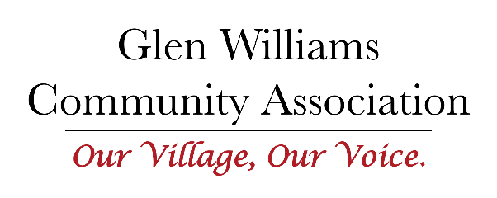
Minutes of the Board Meeting held via Zoom
Wednesday, March 30, 2022, Via Zoom
Mission Statement: To maintain the hamlet character of Glen Williams by engaging and communicating with its residents and other stakeholders.

Meeting called to order at 7:05 p.m.
Present: Joan Griffin; Kate Murray; Jenny Humphreys; Aimee Cichocki; Anthea Hoare; Don Robinson
Regrets: Fernanda Amaral; Derek Remes, Claudia Russell

- Joan Griffin called the meeting to order, and welcomed everyone
Motion to accept and approve the Agenda
Proposed by Anthea Hoare Seconder: Kate Murray Passed

Motion to accept and approve the Minutes of the meeting of February 23, 2022
Proposed by Kate Murray Seconder: Joan Griffin Passed

- Discussion of proposed revised mission statement
Motion to accept and approve the revised Mission Statement
Proposed by Kate Murray Seconder: Aimee Cichocki Passed
Mission Statement: To maintain the hamlet character of Glen Williams by engaging and communicating with its residents and other stakeholders.

- Update on Prince Street Traffic Meeting:
Don Robinson reported that he, Wayne Van Hinte, Kate Murray, and Fernanda Amaral attended. Don Robinson said the meeting went well. The presenters were open to suggestions, and all felt it was a good start to the process.
He also stated that the next meeting of this group will be open to the public.
Joan Griffin thanked all those who participated in the process to date.
Action: Kate Murray will get clarification on how the consultation and communications will roll out.

- GWCA response to Member Concerns about Confederation Street Development
Joan Griffin thanked Don Robinson for all his work on this. Don summarised the results of three exchanges on the issues of density, traffic, and safety.
Don Robinson and Joan Griffin will talk to the Town and clarify the issues and the path forward from here.

- Terms of Reference Presentation from Committee Leads
Communications: General discussion on the presented Terms of Reference for this committee. The Board felt that the plan was good and asked the Committee to prepare the Action Plan.
Development Projects: Don Robinson is overwhelmed with the number of development projects and really would appreciate some good technical help as these need some solid tech skills. Joan Griffin suggested that this request be in the Newsletter.
Beautification: Jenny Humphreys is looking into any resources (e.g., government) and hoping to work with the Glen Williams Town Hall on joint projects. Other suggestions are having historical pointers in the village, and some sort of education to dog owners regarding picking up poop bags. Both Joan Griffin and Aimee Cichocki offered to be on her committee.
Traffic & Roads: Both Kate Murray and Fernanda Amaral are working on this. Need to assess the outcome of the actions identified by the traffic survey, and how to best address them.
(There was considerable discussion of the Community Safety Zone. Joan Griffin suggested that the Terms of Reference be sent to other traffic advocacy groups in the Glen with the invitation to join this committee in order to make it more effective with joint voices.)
Community Engagement: Still under construction as it is a very large committee that is basically in three sections.

It was suggested that all the Terms of Reference be posted on the website once they are all approved.

Executive has suggested that GWCA hold a public Open House to communicate these and other items in the near future.

- Adjournment:
Joan Griffin declared the Meeting Closed at 9:15 p.m.

Next Meeting: Wednesday, April 27, 2022; 7:00 p.m.

